**LAB 5 Gray Level Image Processing I - Thresholding**

**Objectives:**

To get familiar with automatic thresholding techniques

**Review**

* **imhist(‘filename’):** create a histogram
* **graythresh(‘filename’):** computes a global threshold (LEVEL) that can be used to convert an intensity image to a binary image with IM2BW.
* **hist([graindata.Area],20):** Make a histogram containing 20 bins that show the distribution of rice grain sizes. The histogram shows that the most common sizes for rice grains in this image are in the range of 150 to 250 pixels.

**Practice:**

1. **Find suitable thresholding values to get the following segmented results.**

**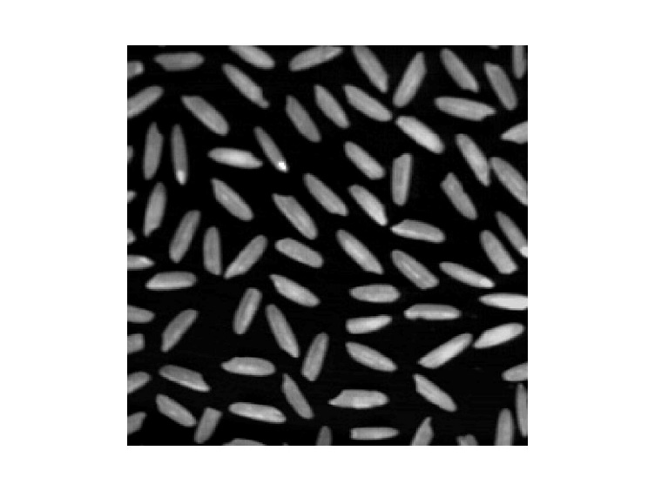**

**Original rice.png image in Matlab**

**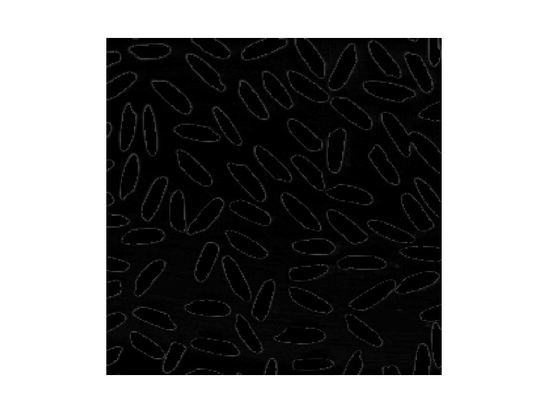 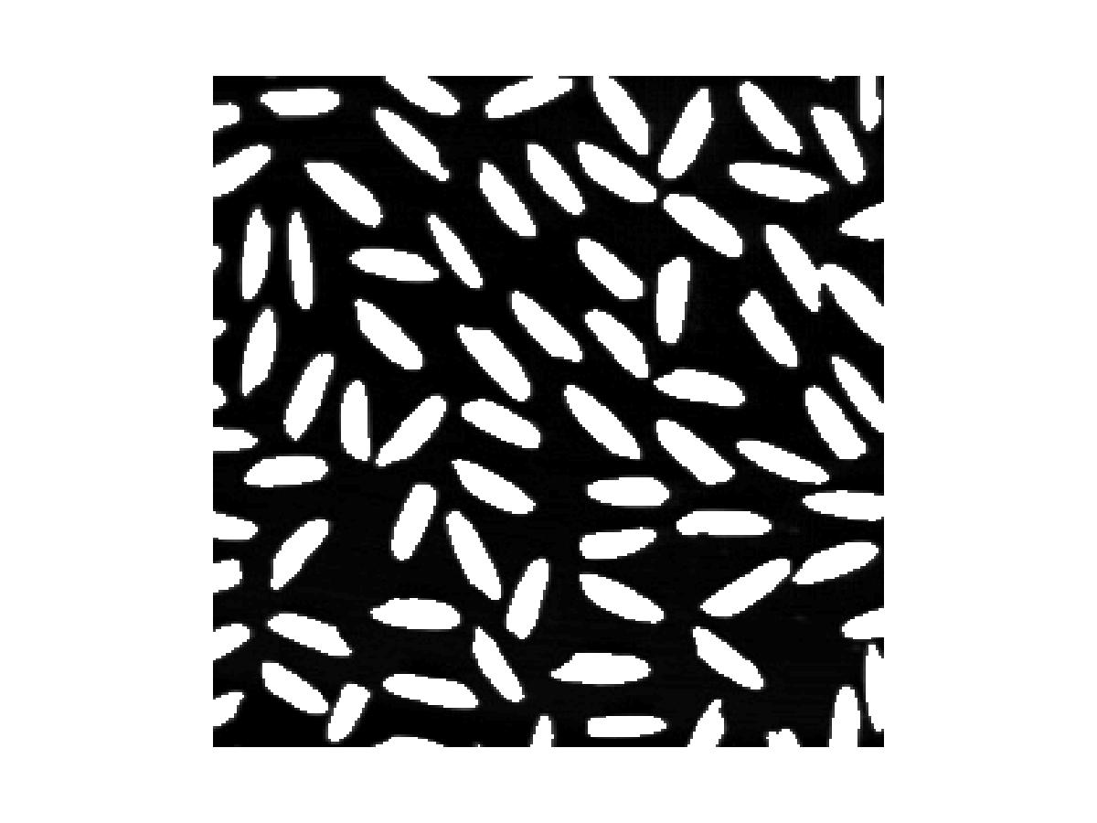**

**Binary image 1 Binary image 2**

1. **Manually find the suitable thresholds for Lena to segment the different parts in image.**

**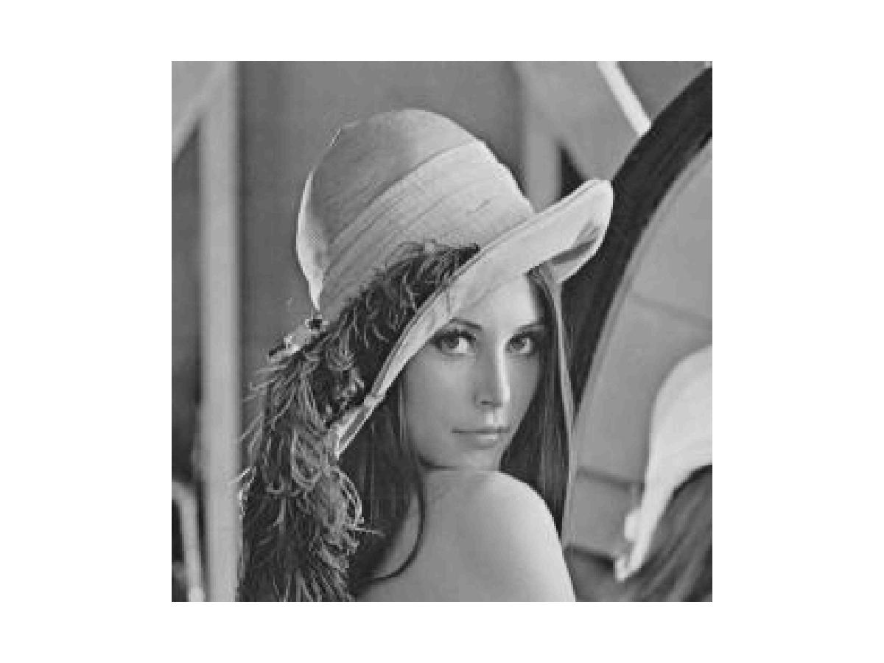 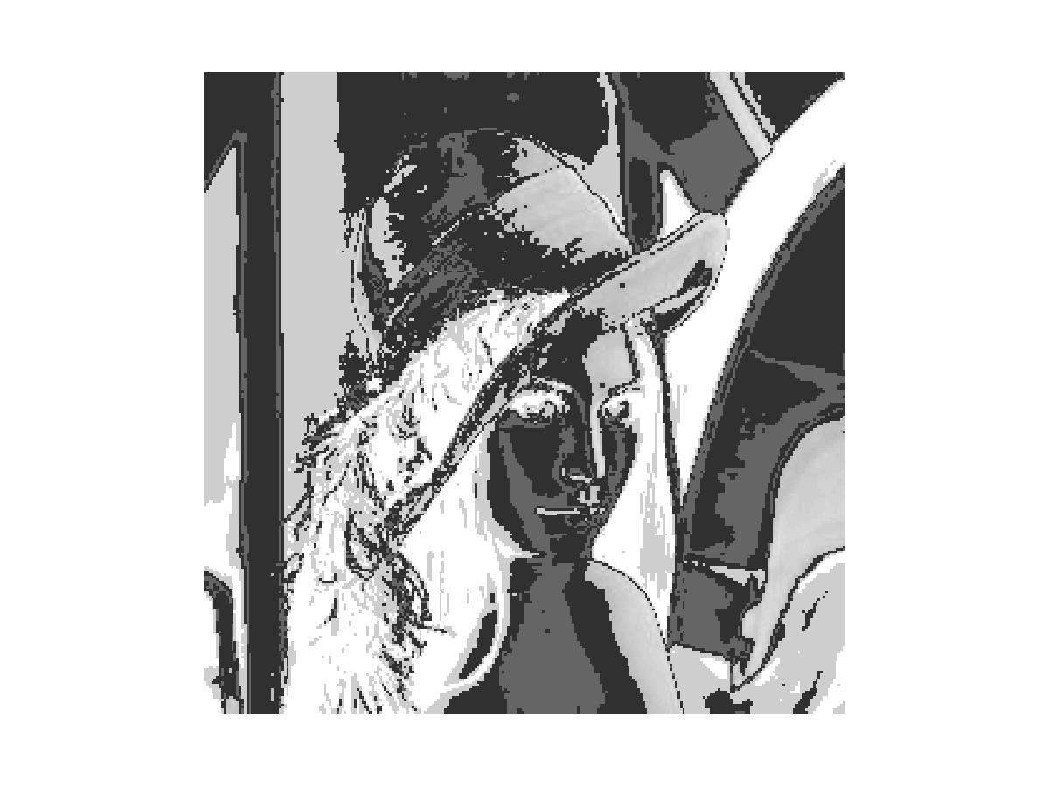**

**Original Lena image Image after thresholding**

1. **Using hysteresis thresholding technique to convert the gray level image cameraman to binary image**

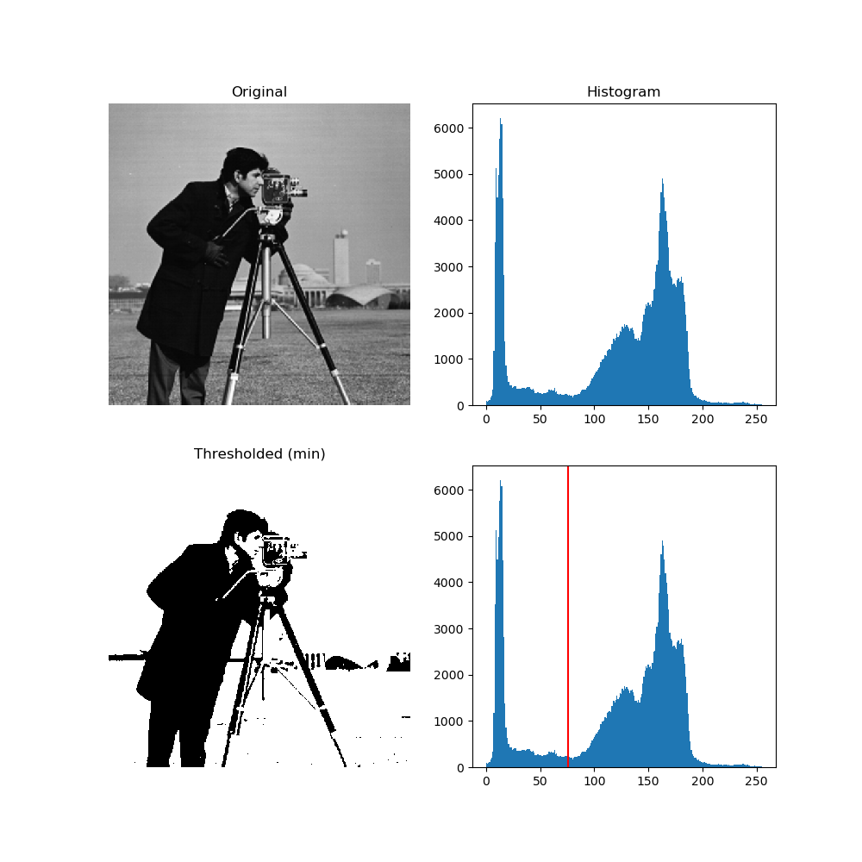

**Exercise: Develop the automatic thresholding program based on the basic global thresholding algorithm in lecture notes. Using the developed program to convert the following gray level image into the binary image.**

**D:\teaching\FST\Courses\ComputerVision\Books\DigitalImageProcessing\DIP3E_Original_Images_CH10\Fig1038(a)(noisy_fingerprint).tif**